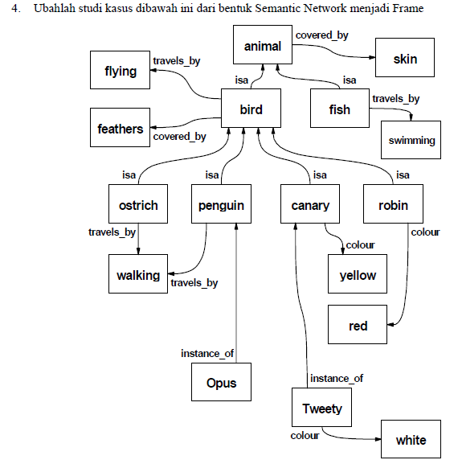

|  |  |
| --- | --- |
| Animal | |
| Covered by | skin |

|  |  |
| --- | --- |
| Bird | |
| Travels_by | Flying |
| Covered_by | feathers |

|  |  |
| --- | --- |
| fish | |
| Travels_by | Swimming |

|  |  |
| --- | --- |
| Ostrich | |
| Travels_by | Walking |

|  |  |
| --- | --- |
| Penguin | |
| Travels_by | Walking |

|  |  |
| --- | --- |
| Canary | |
| Colour | Yellow |

|  |  |
| --- | --- |
| Robin | |
| Colour | Red |

|  |
| --- |
| opus |

|  |  |
| --- | --- |
| Tweety | |
| colour | White |